File 46_region_comsvc_lttrk_prop.csv
May 25, 2026
Definition of the Input File
VisionEval (https://visioneval.github.io/docs/model-inputs.html) explains that This input file defines the proportion of commerical vehicles that are light trucks. This file contains one attribute:
- ComSvcLtTrkProp: Regional proportion of commercial service vehicles that are light trucks
For example, the data below suggest that the proportion of commercial service vehicles that are light trucks in Virginia in 2024 is 0.508967219.
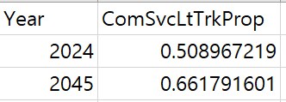
Possible Scenario
Changes to this file would likely be useful for analyzing the impacts of changes in the proportion of commercial service vehicles that are light trucks within the model region. For example, increasing the share of light trucks may lead to higher fuel consumption, energy use, operating costs, and emissions, since light trucks are generally less fuel-efficient than passenger automobiles. Such changes could also affect overall travel costs and vehicle operating characteristics within the model. The document Task 7.2 Simplified Scenario Development guide available at A Playbook for Simplified Approaches for Creating Scenarios in VisionEval does not mentions this file.
Method Used for Virginia
Based on the extrapolation method below, 2024 and 2045 values were estimated using 2021–2023 data.
Several steps were used to develop these data for the 2024 and 2045.
- Source: MV-1 (State motor-vehicle registrations), Highway Statistics 2021-2023, FHWA / VM-1 (Vehicle miles of travel and related data, by highway category and vehicle type), Highway Statistics 2023, FHWA
  - URL: https://www.fhwa.dot.gov/policyinformation/statistics.cfm
  - Location: Resources–Publications and Statistics–Policy Publications– Highways Statistics
  - Search Keyword: Not Applicable
  - Related Sheet: Not Applicable

- Year that the Data Reflect: 2024 (The 2024 value was projected using data from 2021 to 2023.) 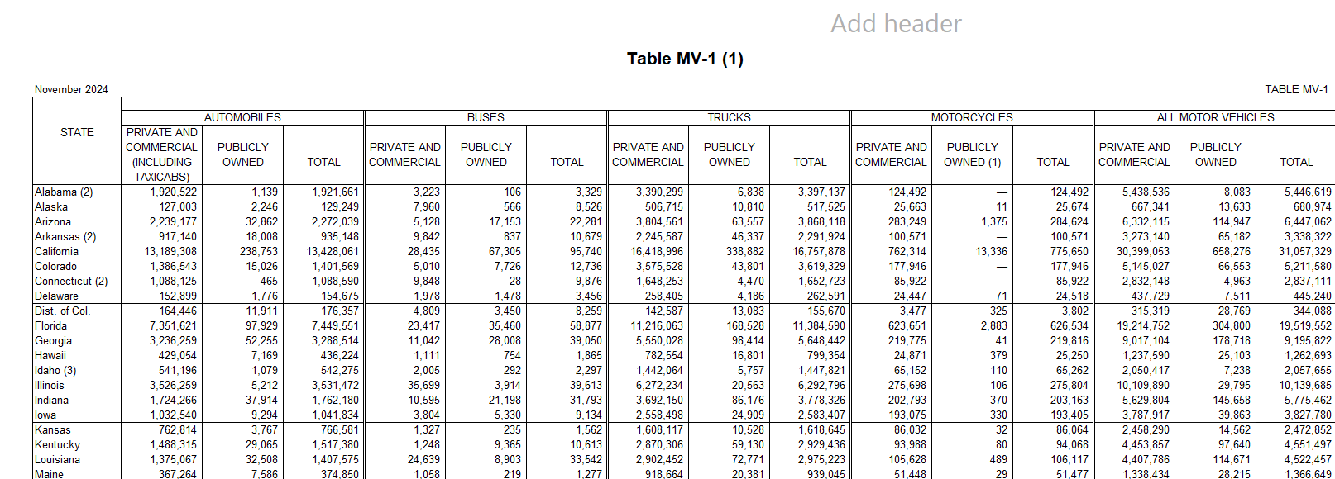
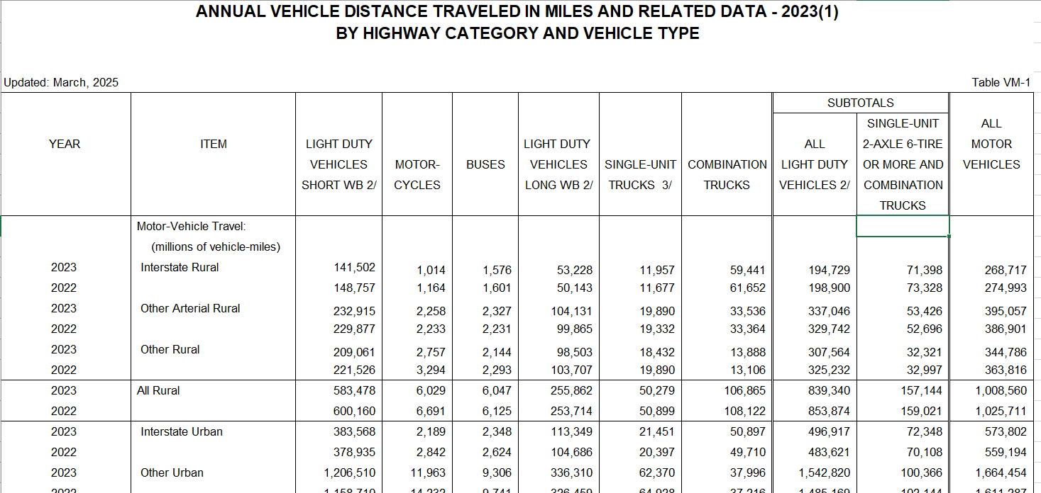

- How the Data Were Processed
  - Commercial Vehicles Assumption: The number of commercial vehicles by type was not available from any known sources. Therefore, the numbers of private and commercial vehicles from FHWA MV-1 were used to estimate the values for 2024 and 2045

  - Base Year and Target Year Values Projection: Both the 2024 base year and the 2045 target year values were projected using the compound annual growth rate (CAGR) calculated from 2021 to 2023 data.
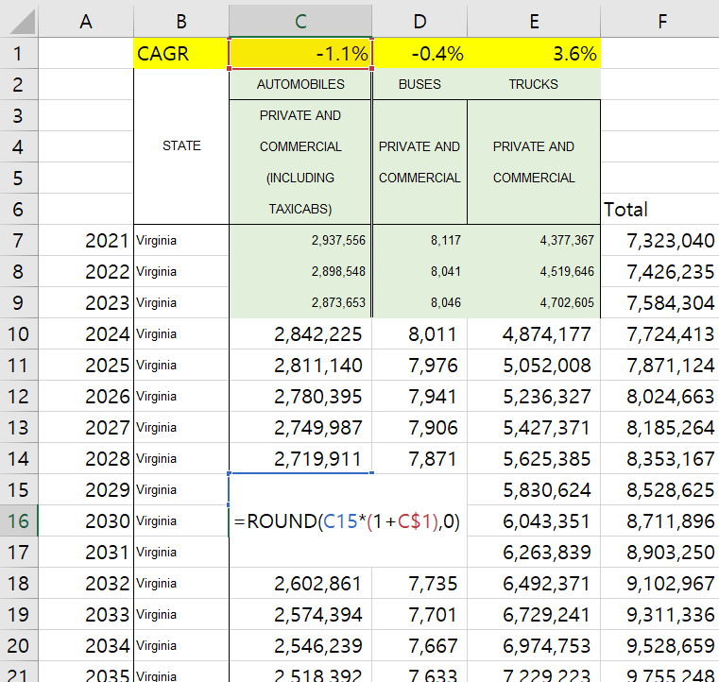

Proportion of Light Trucks: FHWA VM-1 data was used to estimate the proportion of light trucks. Since the VM-1 vehicle classifications differ from those required in this analysis, the vehicle types were mapped accordingly. Although "Light Duty Vehicles Short WB" (vehicles with a wheelbase ≤ 121 inches) include some light trucks, they were excluded from the calculation, as this category also includes automobiles, which may lead to overestimation of the light truck share.
Vehicle Types (VM-1) | Category
Light Duty Vehicles Short WB | Excluded
Motor-Cycles | Excluded
Buses | Excluded
Light Duty Vehicles Long WB | Light Truck
Single-Unit Trucks | Heavy Truck
Combination Trucks | Heavy Truck

  - Light Trucks Proportion Calculation: The proportion of light trucks was estimated to be 80.7%. 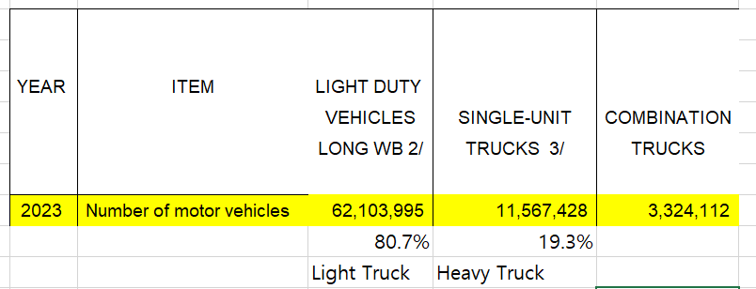
The estimated number of vehicles by type for the base year and target year is summarized below.
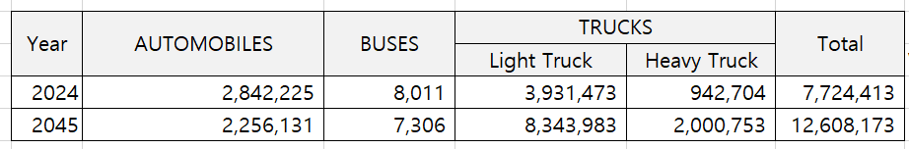

  - Proportion Calculation and Final Result
